**TIME SERIES ANALYSIS FOR ENERGY DEMAND FORECASTING**

Submitted to

**The University of Roehampton**

In partial fulfillment of the requirements

For the degree of

**MASTER OF SCIENCE IN COMPUTING**

**Abstract**

The technique of time series is very valuable to determine the demand for forecasting energy. For making of predictions about demand in the future, entails analyzing data on historical energy consumption to identify patterns, trends, and seasonality. Data collection is the most important part of the time series analysis.

**Declaration**

I hereby certify that this report constitutes my own work, that where the language of others is used, quotation marks so indicate, and that appropriate credit is given where I have used the language, ideas, expressions, or writings of others.

I declare that this report describes the original work that has not been previously presented for the award of any other degree of any other institution.

Signed (apply signature below)

**Date:** 28/07/2023

**SHAMLA KANNACHETH**

**Acknowledgment**

I am very grateful to my friends and my mentors who continuously support me in the analysis of the research time series analysis of energy consumption. They continuously support me in the research on the data collection process. Also, I am very grateful to my parents who have supported me in the most challenging time of the research on time series analysis. They give me confidence for future work.

**TABLE OF CONTENTS**

1.0 Introduction 5

1.1 Introduction 5

1.2 Research Question 5

1.3 Research aim 5

1.4 Research Objectives 5

1.5 Legal, ethical, social and professional considerations 5

1.6 Background 6

1.7 Report Overview 6

2.0 Literature - Technology Review 6

2.1 Literature Review 6

2.2 Technology Review 7

3.0 Methodology 8

4.0 Implementation 9

5.0 Results 10

5.1 Evaluation 10

5.2 Related work 13

6.0 Conclusion 14

6.1 Reflection 14

6.2 Future work 14

Reference List 15

Appendices 17

# 1.0 Introduction

## 1.1 Introduction

The research is based on time series analysis for the demand of energy forecast. The chapter clarifies the research question that has been taken, the aim of the research, and the objectives of the research. Also, the researcher has to consider the legal, ethical, social, and professional demands of the research. The background of the study is also discussed here. Day by day the increasing demand for energy is raising the concern for increasing the environmental degradation issue worldwide.

## 1.2 Research Question

Based on the research of time series analysis for energy demand forecast the researcher has set some research questions. The questions are-

1. How the trend of long-term can be predicted in the energy demand?
2. How the patterns of energy demand can be affected by energy policies?

## 1.3 Research aim

The main aim of the research is to develop advanced modeling techniques thus the demand for energy can be fulfilled. Also, another aim is to identify the forecasting model for energy demand. All the key factors that affect

## 1.4 Research Objectives

The main objective of this research is-

1. To improve the accuracy of forecasting energy demand.
2. To analyze time series for proper analysis of energy demand forecast.
3. To investigate the weather condition factor for forecasting energy.

## 1.5 Legal, ethical, social and professional considerations

**Legal consideration**

The legal consideration that should have to be taken by the researcher is to maintain the privacy of data by implementing proper data protection laws.

**Ethical consideration**

The ethical consideration that has to take is to improve the ethical issues that may be faced by the researcher during the determination of energy forecasting. It is necessary to maintain transparency and equity for all the stakeholders.

**Social consideration**

To promote sustainability in the environment proper strategy and choosing of the proper model is necessary.

**Professional consideration**

The researcher should have knowledge about time series analysis and continuous learning on energy forecasting is necessary. Also, researchers should have to know proper skills in time series analysis.

## 1.6 Background

The technique of time series is very valuable to determine the demand for forecasting energy. It is necessary to select an appropriate model for forecasting energy like ARIMA (“Autoregression Integrated Moving Average”) or LSTM (“Long Short-Term Memory). For the time series analysis, the researcher should have taken various steps. The steps are- it is necessary to collect data, data may be historical data on the consumption of energy (Kim *et al.*2019). The daily, monthly, and yearly data collection help in the process of energy consumption. For the characterization of the collected data, it is important for the exploration of the data. Then it is crucial for the time series decomposition.

## 1.7 Report Overview

The introduction part describes the objectives, aims, questions, and background poof the research study. The upcoming section of the research study is focussing on the description of the literature review, technology review, methodology of the research, implementation, results, and future work of the study.

# 2.0 Literature - Technology Review

## 2.1 Literature Review

According to the author Kim *et al.*2019, time series analysis is a common method for predicting future energy demand. In order to make predictions about demand in the future, entails analyzing data on historical energy consumption to identify patterns, trends, and seasonality. Data collection is the most important part. Collect data on previous energy consumption for a specific time period. The information ought to preferably be gathered at customary spans, like hourly, day-to-day, or month-to-month, contingent upon the degree of detail expected for the examination. It is necessary to investigate the information to figure out its attributes, like patterns, irregularity, and exceptions. The researcher has to imagine the information utilizing plots and diagrams to recognize examples and possible connections.

According to the author Bourdeau *et al.*2019, the researcher also has to clean the information by taking care of missing qualities, and irregularities. Data imputation is required, depending on the particular requirements. Then the time series has to be determined with proper analysis. The researcher can divide the time series into its fundamental parts like residual, trend, and seasonality. This helps in figuring out the general information and catching the hidden design. Based on the data’s characteristics, it is necessary to select the best forecasting model. Models such as Prophet, Exponential Smoothing (ETS), Autoregressive Integrated Moving Average (ARIMA), and Seasonal ARIMA (SARIMA) are frequently utilized for energy demand forecasting.

## 2.2 Technology Review

According to the author, Le *et al.*2019 technology review considers the technological aspects. The energy providers and policymakers are able to make well-informed decisions regarding resource allocation, infrastructure planning, and energy management for time series analysis, which plays a crucial role in forecasting energy demand. ARIMA models combine autoregressive and moving normal parts and handle non-fixed time series through differencing. This model has been broadly utilized for energy forecasting determination (Alhussein *et al.*2020). There is another alternative model of ARIMA which is SARIMA (“seasonal Autoregressive Integrated Moving Average). The model SARIMA is suitable for capturing periodic patterns in energy demands because it extends ARIMA models by taking seasonality into account in the data.

According to the author Zhong *et al.*2019, the Machine Learning (ML) technique is also used for forecasting energy demand. In the machine learning techniques, there are various models that are responsible for energy forecasting. The models are- SVR (“Support Vector Relapse”), LSTM (“Long-Short-Term Memory”), CNN (“Convolutional Neural Network”), etc. SVR uses a support vector machine for relap[se activity. It has been applied to time series determining by changing the information into a higher-layered space utilizing bit capabilities. Based on the LSTM model, long-term dependencies in time data can be captured by the recurrent neural network architecture known as LSTM. It has demonstrated promising results, particularly for capturing sequential patterns, in energy demand forecasting. The model CNN, ordinarily utilized for picture examination, has been adjusted for time series determined by regarding the information as a picture-like portrayal. From the input time series, this model is able to solve meaningful features and patterns.

# 3.0 Methodology

The methodology of a research study discusses the procedures that are taken to perform the research of time analysis for energy demand forecast. Proper planning and procedure are taken to perform the research on time by following a strategic manner. To determine proper strategic objectives, the researcher must follow a proper research philosophy. The knowledge development is dependent on the research philosophy. The philosophy of research that is taken for this time series analysis is the Positivism research philosophy (Sajjad *et al.*2020). By applying this philosophy the researcher can take the quantitative data for the analysis of research. This philosophy helps to use different variables for the analysis of the research. Then comes the research approach. Through the research approach the assumptions of the data collection, the analysis of the collected data, and the interpretation of the result would be possible, The research approach that is taken for the research is the inductive research approach.

With this research approach, the researcher can collect the data and easily analyze data. The concepts and theories regarding data collection may be possible. For the time series analysis, the researcher has to take quantitative data (Lara-Benítez *et al.*2021). The numeric data collection will help properly for the research analysis. The research design that is taken to perform the research strategy is secondary research analysis. For the collection of secondary data, the researcher can take the help of internet resources, google scholar, etc. Then comes the data collection method. For the data collection process, the researcher has to collect historical data.

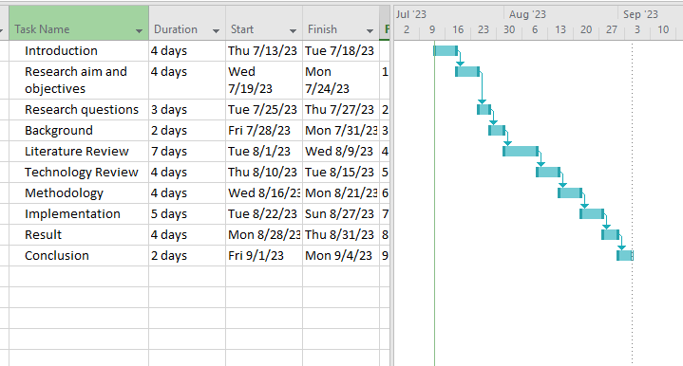

**Figure 1: Research Timeline**

(Source: Self-Created in MS-Project)

# 4.0 Implementation

There are various implementations of the research of time series analysis for energy forecasting. Future energy demand forecasts will need to take into account the intermittent nature of renewable energy sources as they become more common. The availability and variability of renewable energy sources can be incorporated into time series analysis models, facilitating improved energy system planning and management. With the rising accessibility of constant information, energy request estimates can be refreshed and refined ceaselessly (Aslam *et al.*2021). This capability of real-time forecasting enables proactive strategies to optimize energy generation, distribution, and consumption as well as more nimble decision-making in energy management. The developed perception methods can assist researchers with better comprehension and solve energy forecasting. Researchers can explore various scenarios and evaluate the impact of their choices with the help of interactive dashboards and visual representations, which can facilitate decision-making processes.

By identifying the patterns and relationships in energy demand data, the application of machine learning and artificial intelligence techniques can contribute to an improvement in forecasting accuracy. Advanced algorithms are able to automatically learn from past data, adjust to new patterns, and make predictions that are more accurate. Future work might include further investigating and refining these profound learning models for energy request expectation. Time series analysis for energy forecasting can be improved by integrating outside factors that impact energy utilization (Sun *et al.*2020). Changes in demographics, economic indicators, and weather are all examples of this. To increase precision, advanced models may incorporate these elements into the forecasting procedure. Future work might include creating progressed strategies to appraise and spread vulnerability through time series models, or probabilistic estimating procedures.

# 5.0 Results

## 5.1 Evaluation

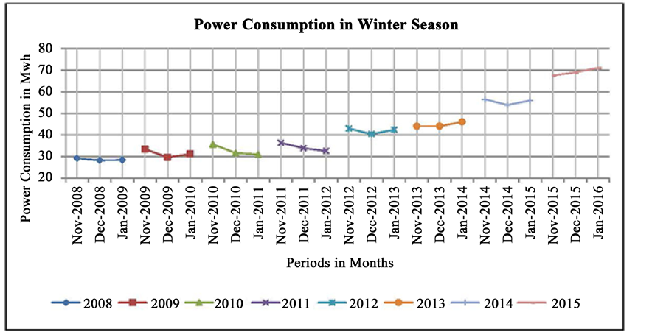

**Figure 2: Consumption of energy in winter**

(Source: https://th.bing.com)

The above figure is the chart of energy consumption in the season of winter. The chart is a total time series analysis of energy consumption. The chart shows the graph of power (energy) consumption versus periods in a month. The data shows starting from the year 2008 to 2015. On November 2008 it has been observed that the energy consumption is 30 Mwh. In the month of January 2011, there is observed an increase in energy consumption that is 35 Mwh. In December 2012 energy consumption is 40 Mwh. In December 2014 energy consumption is 55Mwh. In 2016 there is observed a massive energy increase (Ahn *et al.*2022). The energy is 70 Mwh.From November 2008 to January 2016 analysis it is observed that it is a slow and continuous increase of the rate of energy consumption. In January 2016 there is a massive increase in the rate of energy consumption.

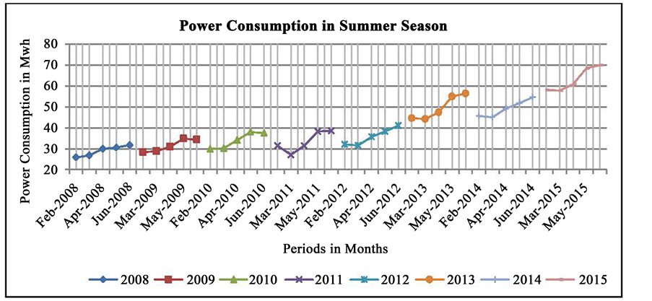

**Figure 3: Consumption of energy in summer**

(Source: https://th.bing.com)

The above figure is the chart of energy consumption in the season of summer. The chart is a total time series analysis of energy consumption. The chart shows the graph of power (energy) consumption versus periods in a month. The data shows starting from the year 2008 to 2015. On February 2008 it has been observed that the energy consumption is 25 Mwh. In the month of March 2011, there is observed an increase in energy consumption that is 40 Mwh. In March 2013 energy consumption is 59 Mwh. In March 2015 energy consumption is 55Mwh. In May 2015 there is an observed massive energy increase (Wu *et al.*2020). The energy is 70 Mwh.From February 2008 to May 2015 analysis it is observed that it is a slow and continuous increase of the rate of energy consumption.

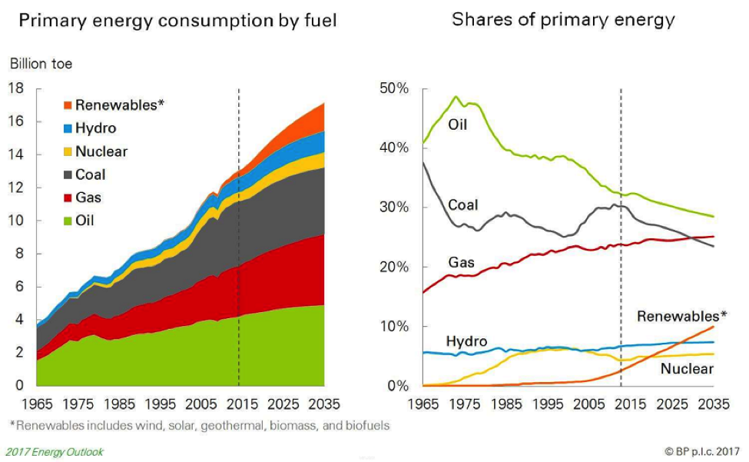

**Figure 4: Energy consumption and its share**

(Source: https://th.bing.com)

According to the above figure, there is the amount of the primary energy consumption by the fuel throughout the past years and the upcoming year also. It has been observed that the energy consumption rate is calculated for renewables, hydro energy, nuclear energy, coal consumption, gas energy, and for oil consumption. There is also a given share of primary energy. The share of nuclear energy in the year 1965 is 0% and in 2035 it would be 10%. The hydro energy consumption in the year 1965 was 5% and in 2035 would be 11%. The gas consumption in the year 1965 was 17% and in 2035 would be 22%. Coal energy consumption in the year 1965 was 39% and in 2035 would be 21% (Challu *et al.*2023). Oil energy consumption in 1965 was 40% and in 2035 it would be 31%. So, after the analysis, it has been observed that the coal energy consumption and the oil energy consumption would decrease. But there would be an increment in gas and renewable energy consumption. As the amount of non-renewable energy resources decreases day by day.

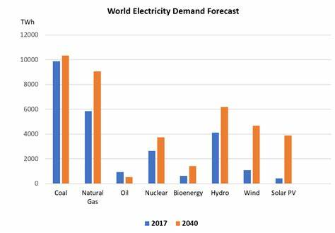

**Figure 5: World Electricity Demand Forecast**

(Source: https://th.bing.com)

The above figure is the description of the world electricity demand forecast. It is also energy demand forecasting. From the above figure, it is observed that in the year 2017, the energy consumption rate by coal is 10000 Twh, by natural gas is 6000 Twh, by oil is 1000 Twh, by nuclear energy is 2100 Twh, by bioenergy is 500 Twh, by hydro energy is 400 Twh, by wind energy is 500 Twh, by Solar PV is 10 Twh. It is observed that the energy consumption rate by coal is highest than the other. The smallest energy consumption rate is for solar PV. Because it is renewable energy resources. Also, the energy consumption rate for then wind energy is less. The researcher has predicted a forecast that the energy consumption rate in the year 2040 may be of the following (Zeng *et al.*2023). In the year 2040, the energy consumption rate for coal would be 11000 Twh, for natural gas would be 6000 Twh, for oil it would be 5 Twh, for nuclear energy it would be 4000 Twh, for bioenergy it would be 1500 Twh, for Hydro energy it would be 600 Twh, for wind energy it would be 4500 Twh, solar PV it would be 4000 Twh. The energy consumption rate from solar PV would also increase in the year 2040.

## 5.2 Related work

The related work of research on time series analysis is the future implementation of this research. Future work can investigate progressive and spatial-transient displaying ways to deal with catch the spatial conditions and differentiate in energy interest. This could include procedures like spatial autoregressive models, diagram brain organizations, or geostatistical techniques.

# 6.0 Conclusion

## 6.1 Reflection

The research on the time series analysis helps me to identify the proper strategic plan to determine energy forecasting. From the research analysis, I can understand the implementation of this research and the energy consumption value throughout the world by proper strategic time series analysis. The technology review analysis help me to understand the models that are used for the analysis of the forecasting of energy demand.

## 6.2 Future work

There are various future works that can be progressed with the help of the implementation of time series analysis. Future work might include further investigating and refining these profound learning models for energy request expectation. The mix of consideration systems and transformer models might upgrade the capacity to catch complex examples and conditions in energy information. Future work might include creating progressed strategies to appraise and spread vulnerability through time series models, or probabilistic estimating procedures. Future work might include creating procedures that can deal with high-recurrence information, catch unexpected changes in energy request designs, and give dependable transient expectations.

# Reference List

**Journals**

Kim, T.Y. and Cho, S.B., 2019. Predicting residential energy consumption using CNN-LSTM neural networks. *Energy*, *182*, pp.72-81.

Le, T., Vo, M.T., Vo, B., Hwang, E., Rho, S. and Baik, S.W., 2019. Improving electric energy consumption prediction using CNN and Bi-LSTM. *Applied Sciences*, *9*(20), p.4237.

Bourdeau, M., qiang Zhai, X., Nefzaoui, E., Guo, X. and Chatellier, P., 2019. Modeling and forecasting building energy consumption: A review of data-driven techniques. *Sustainable Cities and Society*, *48*, p.101533.

Zhong, H., Wang, J., Jia, H., Mu, Y. and Lv, S., 2019. Vector field-based support vector regression for building energy consumption prediction. *Applied Energy*, *242*, pp.403-414.

Li, S., Jin, X., Xuan, Y., Zhou, X., Chen, W., Wang, Y.X. and Yan, X., 2019. Enhancing the locality and breaking the memory bottleneck of transformer on time series forecasting. *Advances in neural information processing systems*, *32*.

Alhussein, M., Aurangzeb, K. and Haider, S.I., 2020. Hybrid CNN-LSTM model for short-term individual household load forecasting. *Ieee Access*, *8*, pp.180544-180557.

Sajjad, M., Khan, Z.A., Ullah, A., Hussain, T., Ullah, W., Lee, M.Y. and Baik, S.W., 2020. A novel CNN-GRU-based hybrid approach for short-term residential load forecasting. *Ieee Access*, *8*, pp.143759-143768.

Lara-Benítez, P., Carranza-García, M. and Riquelme, J.C., 2021. An experimental review on deep learning architectures for time series forecasting. *International journal of neural systems*, *31*(03), p.2130001.

Aslam, S., Herodotou, H., Mohsin, S.M., Javaid, N., Ashraf, N. and Aslam, S., 2021. A survey on deep learning methods for power load and renewable energy forecasting in smart microgrids. *Renewable and Sustainable Energy Reviews*, *144*, p.110992.

Sun, Y., Haghighat, F. and Fung, B.C., 2020. A review of the-state-of-the-art in data-driven approaches for building energy prediction. *Energy and Buildings*, *221*, p.110022.

Ahn, H., Sun, K. and Kim, K., 2022. Comparison of missing data imputation methods in time series forecasting. *Computers, Materials & Continua*, *70*(1), pp.767-779.

Wu, Z., Pan, S., Long, G., Jiang, J., Chang, X. and Zhang, C., 2020, August. Connecting the dots: Multivariate time series forecasting with graph neural networks. In *Proceedings of the 26th ACM SIGKDD international conference on knowledge discovery & data mining* (pp. 753-763).

Challu, C., Olivares, K.G., Oreshkin, B.N., Ramirez, F.G., Canseco, M.M. and Dubrawski, A., 2023, June. NHITS: Neural Hierarchical Interpolation for Time Series Forecasting. In *Proceedings of the AAAI Conference on Artificial Intelligence* (Vol. 37, No. 6, pp. 6989-6997).

Zeng, A., Chen, M., Zhang, L. and Xu, Q., 2023, June. Are transformers effective for time series forecasting?. In *Proceedings of the AAAI conference on artificial intelligence* (Vol. 37, No. 9, pp. 11121-11128).

Abbasi, K.R., Shahbaz, M., Jiao, Z. and Tufail, M., 2021. How energy consumption, industrial growth, urbanization, and CO2 emissions affect economic growth in Pakistan? A novel dynamic ARDL simulations approach. *Energy*, *221*, p.119793.

# Appendices

**Appendix 1: Global Energy Demand**

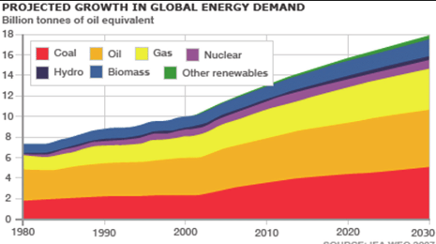

(Source: https://www.researchgate.net)